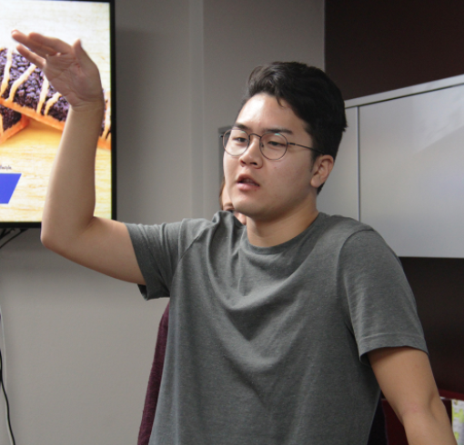
Please write a grammatically correctly complete cutline for each of the photos below using the information supplied. Please be careful with proper and common nouns and present tense verbs. If you feel something is missing please explain what it is.

1. (photo by Kevin Garcia)
Information:
John Lee,
Mass Communication Week,
explains what social media is,
newspaper/radio station building

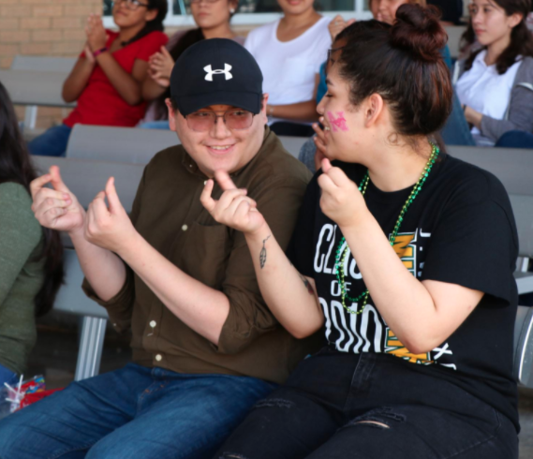

2. (photo by Lucero Rea)
Information:
Anthony Berrones, Andrea Guajardo
third annual Fright Mic
Outdoor stage
snapping fingers
poetry reading
Oct. 13

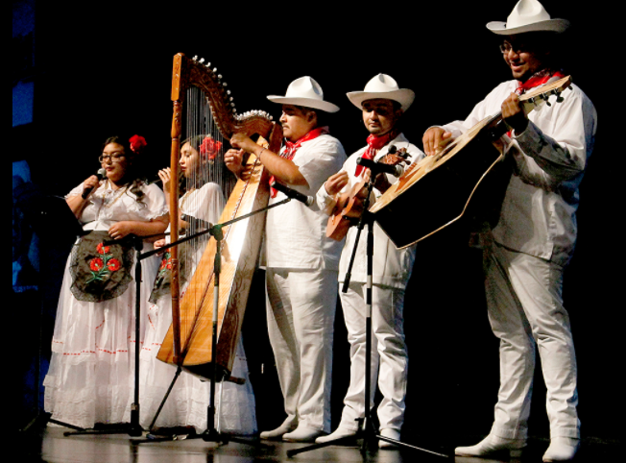
3. (photo by Xochitl Gonzalez)
Grupo Jarocho
traditional music
16 de septiembre celebration
afternoon
auditorium

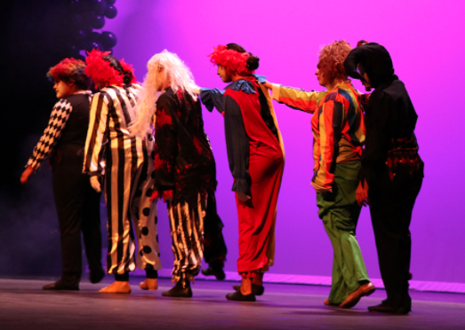

4. (photo by Addy Melgar)
Dance students
perform dance number
American Horror Stories
Oct. 25
auditorium
morning

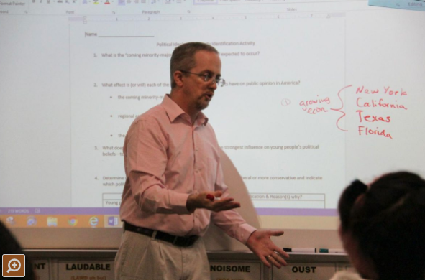

5. (photo by Briana Sepulveda)
AP instructor Sean Gaynor
first block
presents lesson
classroom
grades AP exams

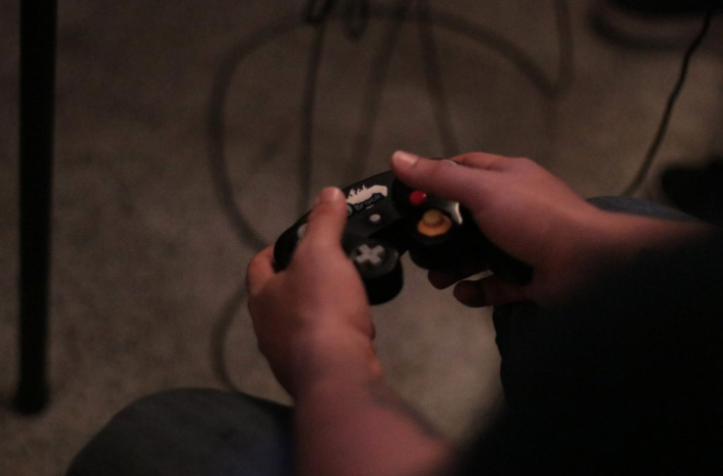
6. (photo by Manuel Ruiz)
tournament player
Super Smash Bros.
Seikatsu Gaming Lounge

