Cutline exercise

Cutline — A newspaper term. It’s a sentence or more of explanation located below a photograph. They’re otherwise known as a caption.

Remember that cutlines must have at least a subject, usually a verb in the present tense, and object.

Online, all photos in a series must have complete cutlines.

Whenever possible, please get the names of people in the photograph.

Don’t forget to use whatever is appropriate from these journalism elements: Who-What-Where-When-Why-How

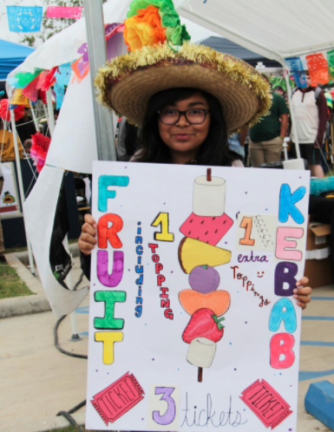
Example 1
Example of a cutline.
(Photo by Aryanna Rodriguez)

A (fine arts area) student promotes her fruit kebab booth during the Hispanic Heritage Festival on Nov. 8 in the school’s south parking lot.

Who: (fine arts area) student. Name would be better.

Where: south parking lot

What: fruit kebab booth, Hispanic Heritage Festival

When: Nov. 8

Why, How: (not relevant)
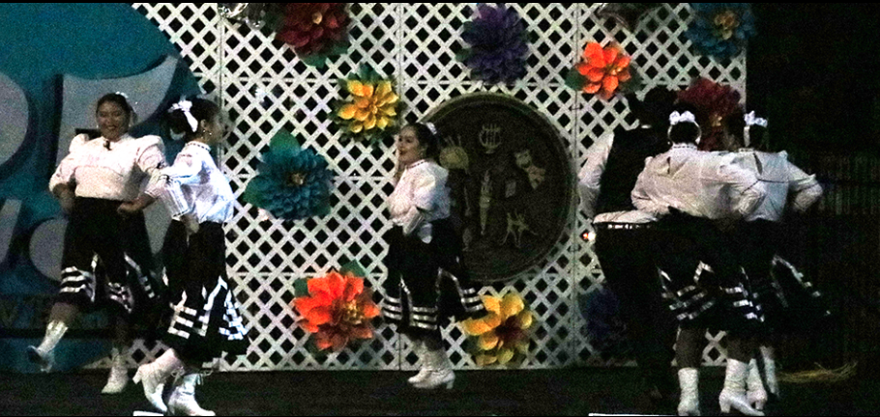

Example 2
(Photo by Anna Davenport)

Dance students perform a traditional dance at the Hispanic Heritage Festival in the school’s south parking lot on Nov. 8.

Who: dance students

What: traditional dance, Hispanic Heritage Festival

Where: school’s south parking lot When: Nov. 8 Why and How: (not relevant)

